 |  | 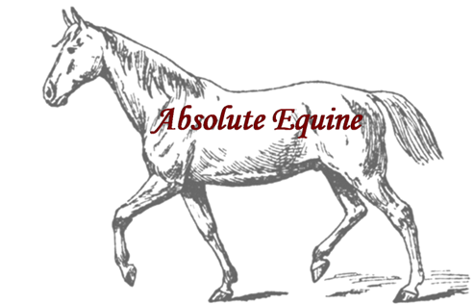
Credit Card Authorization Form
Please complete all information below. You may cancel this authorization at any time by e mailing
us at billing@dfwabsoluteequine.com This authorization will remain in effect until it is cancelled.
 | Card type (Circle one): |  |  | MC | Visa | Amex | Discover
 | Credit Card Number:___________________________________________________
 | Exp. Date:__________ |  | CVV Code:_________
 | Credit Card Billing Address With Zip Code:________________________________
 | _____________________________________________________________________
I, ______________________________ authorize Absolute Equine to charge my credit card for any
open invoices. I understand that my information will be saved for future transactions on my
account.
Signature:___________________________________________ |  |  |  |  |  | Date:__________________

